|  |  |
| --- | --- |
| Activity | Data Type |
| Number of beatings from Wife | Discrete |
| Results of rolling a dice | Discrete |
| Weight of a person | Continuous |
| Weight of Gold | Continuous |
| Distance between two places | Continuous |
| Length of a leaf | Continuous |
| Dog's weight | Continuous |
| Blue Color | Categorical |
| Number of kids | Discrete |
| Number of tickets in Indian railways | Discrete |
| Number of times married | Discrete |
| Gender (Male or Female) | Categorical |

Q1) Identify the Data type for the Following:

Q2) Identify the Data types, which were among the following

Nominal, Ordinal, Interval, Ratio.

|  |  |
| --- | --- |
| Data | Data Type |
| Gender | Nominal |
| High School Class Ranking | Ordinal |
| Celsius Temperature | Interval |
| Weight | Ratio |
| Hair Color | Nominal |
| Socioeconomic Status | Nominal |
| Fahrenheit Temperature | Interval |
| Height | Ratio |
| Type of living accommodation | Nominal |
| Level of Agreement | Ordinal |
| IQ(Intelligence Scale) | Interval |
| Sales Figures | Ratio |
| Blood Group | Nominal |
| Time Of Day | Ordinal |
| Time on a Clock with Hands | Interval |
| Number of Children | Ratio |
| Religious Preference | Nominal |
| Barometer Pressure | Ratio |
| SAT Scores | Interval |
| Years of Education | Ratio |

Q3) Three Coins are tossed, find the probability that two heads and one tail are obtained?

Answer) The total possible outcome 23 = 8

HHH,HHT,HTT,THT,TTH,HTH,THH,TTT

Number of favorable outcomes = 3

P(two head and one tail) = 3/8

Q4) Two Dice are rolled, find the probability that sum is

1. Equal to 1
2. Less than or equal to 4
3. Sum is divisible by 2 and 3

Answer) Total number of outcome = 36

1. Number of outcomes sum equal to 1 = 0

P(equal to 1) = 0/36

1. Number of outcomes sum is less than or equal to 4 = 6

P(Less than or equal to 4) = 6/36 = 1/6

1. Number of outcomes sum is divisible by 2 and 3 = 6

P(Sum is divisible by 2 and 3) = 6/36 = 1/6

Q5) A bag contains 2 red, 3 green and 2 blue balls. Two balls are drawn at random. What is the probability that none of the balls drawn is blue?

Answer) Total ways to draw 2 balls = 7C2 = 21

Ways to draw 2 non-blue balls = 5C2 = 10

P(none of the balls drawn is blue) = 10/21

Q6) Calculate the Expected number of candies for a randomly selected child

Below are the probabilities of count of candies for children (ignoring the nature of the child-Generalized view)

|  |  |  |
| --- | --- | --- |
| CHILD | Candies count | Probability |
| A | 1 | 0.015 |
| B | 4 | 0.20 |
| C | 3 | 0.65 |
| D | 5 | 0.005 |
| E | 6 | 0.01 |
| F | 2 | 0.120 |

Child A – probability of having 1 candy = 0.015.

Child B – probability of having 4 candies = 0.20

Answer) Expected number of candies for a randomly selected child

=1*0.015 + 4*0.20 + 3*0.65 + 5*0.005 + 6*0.01 + 2*0.120

= 0.015 + 0.8 + 1.95 + 0.025 + 0.06 + 0.24

= 3.09

Q7) Calculate Mean, Median, Mode, Variance, Standard Deviation, Range & comment about the values / draw inferences, for the given dataset

* For Points,Score,Weigh>

Find Mean, Median, Mode, Variance, Standard Deviation, and Range and also Comment about the values/ Draw some inferences.

**Use Q7.csv file**

Answer) **Point**: Mean = 3.605758, Median = 3.695, Mode = 3.92,

Variance = 0.2858814, Standard deviation = 0.5346787

**Score**: Mean = 3.199152, Median = 3.325, Mode = 3.44,

Variance = 0.957379, Standard deviation = 0.9784574

**Weight:** Mean = 17.80667, Median = 17.71, Mode = 17.02,

Variance = 3.193166, Standard deviation = 1.786943

Q8) Calculate Expected Value for the problem below

1. The weights (X) of patients at a clinic (in pounds), are

108, 110, 123, 134, 135, 145, 167, 187, 199

Assume one of the patients is chosen at random. What is the Expected Value of the Weight of that patient?

Answer) Expected value = Sum (X * Probability of X) = (1/9)(108)+ (1/9)(110)+ (1/9)(123)+ (1/9)(134)+ (1/9)(145)+ (1/9)(167)+ (1/9)(187)+ (1/9)(199) = 145.33

**Q9) Calculate Skewness, Kurtosis & draw inferences on the following data**

**Cars speed and distance**

**Use Q9_a.csv**

**SP and Weight(WT)**

**Use Q9_b.csv**

Answer) Speed

Skewness : -0.11395477

Kurtosis : -0.50899442

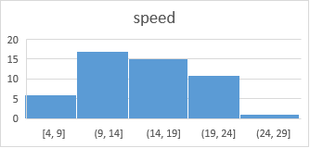

Distance

Skewness : 0.80689496

Kurtosis : 0.405052582

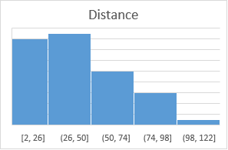

SP

Skewness : 1.581453679

Kurtosis : 2.977328944

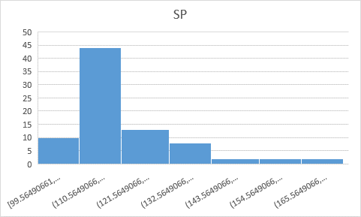

WT

Skewness : -0.603309932

Kurtosis : 0.950291491

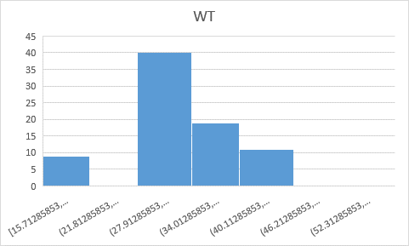

**Q10) Draw inferences about the following boxplot & histogram**



Answer) Chick weight data is right skewed or positively skewed.

The interface for this box plot is right skewed. There are outliers at upper side.

**Q11)** Suppose we want to estimate the average weight of an adult male in Mexico. We draw a random sample of 2,000 men from a population of 3,000,000 men and weigh them. We find that the average person in our sample weighs 200 pounds, and the standard deviation of the sample is 30 pounds. Calculate 94%,98%,96% confidence interval?

Answer) Confidence interval of 94% is [198.74-201.26]

Confidence interval of 94% is [198.62-201.38]

Confidence interval of 94% is [198.43-201.56]

**Q12)** Below are the scores obtained by a student in tests

**34,36,36,38,38,39,39,40,40,41,41,41,41,42,42,45,49,56**

1. Find mean, median, variance, standard deviation.
2. What can we say about the student marks?

Answer)1) Mean -41

Median – 40.5

Variance – 25.52941176

Standard Deviation - 5.052663829

2) Mass of students marks between 38-42.

Skewness(1.542884681) is positive because mass of student marks in left side of the plot.

Q13) What is the nature of skewness when mean, median of data are equal?

Answer) Data is normalized and there is no skewness.

Q14) What is the nature of skewness when mean > median ?

Answer) Negative skewness implies mass of distribution on the right side.

Q15) What is the nature of skewness when median > mean?

Answer) Positive skewness implies mass of distribution on the left side.

Q16) What does positive kurtosis value indicates for a data ?

Answer) Positive kurtosis value indicates thinner peak and wider tails.

Q17) What does negative kurtosis value indicates for a data?

Answer) Negative kurtosis value indicates wider tail and thinner tails.

Q18) Answer the below questions using the below boxplot visualization.



What can we say about the distribution of the data?

Answer) Not normally distributed

What is nature of skewness of the data?

Answer) Negative skewness

What will be the IQR of the data (approximately)?

Answer) 10 - 18

Q19) Comment on the below Boxplot visualizations?



Draw an Inference from the distribution of data for Boxplot 1 with respect Boxplot 2.

Answer)

Q 20) Calculate probability from the given dataset for the below cases

Data _set: Cars.csv

Calculate the probability of MPG of Cars for the below cases.

MPG <- Cars$MPG

* 1. P(MPG>38)
  2. P(MPG<40)

c. P (20<MPG<50)

Q 21) Check whether the data follows normal distribution

1. Check whether the MPG of Cars follows Normal Distribution

Dataset: Cars.csv

1. Check Whether the Adipose Tissue (AT) and Waist Circumference(Waist) from wc-at data set follows Normal Distribution

Dataset: wc-at.csv

Q 22) Calculate the Z scores of 90% confidence interval,94% confidence interval, 60% confidence interval

Answer) Confidence interval of 60% - 0.8416212

Confidence interval of 90% - 1.644854

Confidence interval of 94% - 1.880794

Q 23) Calculate the t scores of 95% confidence interval, 96% confidence interval, 99% confidence interval for sample size of 25

Answer) Confidence interval of 95% - 2.063899

Confidence interval of 96% - 2.171545

Confidence interval of 99% - 2.79694

Q 24**)** A Government company claims that an average light bulb lasts 270 days. A researcher randomly selects 18 bulbs for testing. The sampled bulbs last an average of 260 days, with a standard deviation of 90 days. If the CEO's claim were true, what is the probability that 18 randomly selected bulbs would have an average life of no more than 260 days

Hint:

rcode 🡪 pt(tscore,df)

df 🡪 degrees of freedom

Answer) 52